Lecture 3 - Diodes

DIODES (also known as “rectifier”)

Symbol: 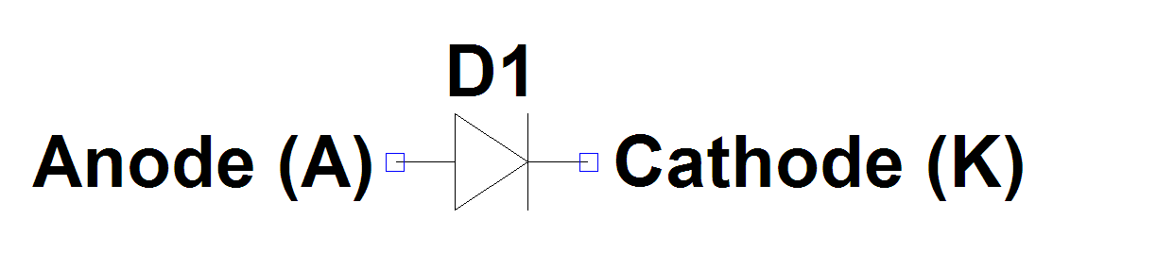
Functions in Switching Circuits:
- As a rectifier (converter AC to DC)
- As a freewheel path for inductive currents.

Behaviour:
Approx 0.7V
Volts (A-K)
Amps (A-K)
Limitations:
Maximum Blocking Voltage
Maximum Peak Forward current
Maximum Average Forward Current (limited by thermal considerations)

Losses:
Conduction losses are caused by the forward voltage drop. Although we often think of 0.7V as a typical forward voltage in power applications where the diode is carrying significant current forward voltage drops of 1V or above are common.

Diodes turn on very quickly at low forward voltages so turn on switching losses are negligible. Standard silicon diodes exhibit a slow reverse recovery on turn off that can be problematic in switching circuits.

Reverse Recovery:

When a normal silicon diode (PN junction) is forward biased the junction region becomes flooded with minority charge carriers. If the voltage is reversed these carriers must be removed from the junction to form a depletion layer in order for the diode to start blocking. The diode will actually conduct in the reverse direction for a small time after negative voltage is applied until the stored charge is removed.
time
V_{AK}
I_{KA}
t_{rr}
I_{RR}
Stored Charge Q_{RR ≅} ½I_{RR}t_{rr}

I_{RR =} The peak reverse recovery current
T_{rr} = the revere recovery time,
Q_{RR} = The stored charge that must be removed before diode starts blocking.

Reverse recovery causes a number of problems in switching power systems:
1. If t_{rr}is a significant proportion of the switching cycle (T_{switch}) then the circuit may not work at all because the diode does not block.
2. Reverse recovery causes increased losses. For example in a step down DC/DC converter the peak reverse recovery current I_{RR} adds to the current in the main switch while it is turning on. This greatly increases the turn on losses of the main switch.
3. In some diodes the reverse recovery current decays very suddenly (snaps off) this high di/dt can cause very high voltage spikes in any circuit inductance.

Types of Diode:
Signal Diode (eg 1n4148): Low current (<100mA) fast diode, too weak for most power converters
Standard Diode: (eg 1N4050): available in 1A to k. Robust, slow recovery. Only suitable for use in low frequency (50Hz) rectifiers.
Fast Recovery and Ultrafast recovery: t_{rr}less than 1us. Designed for use in high frequency switch mode converters - switching frequency up to 100's kHz. Less robust than standard diodes - lower peak current capability.
Soft Recovery: Fast or ultrafast recovery diode optimised for gentle trun off of reverse current. Recommended for most high frequency switching applications to avoid problem of high di/dt.

Alternatives to standard PN diodes for overcoming conduction losses
In low voltage circuits the 0.7V drop of a standard diode is unacceptable. Modern microprocessors for example require 1.5V supplies and a 0.7V diode drop would consume almost half of the available voltage.

- Schottky diodes use a metal semiconductor junction (schottky barrier) rather than a PN junction. They have a forward voltage drop typically half that of an equivalent PN diode. Also they do not suffer from charge storage. Schottky’s suffer from high reverse leakage and are only suitable for use in low voltage circuits (up to 100V).
- Synchronous rectifiers use a mosfet switch with an appropriate control circuit to turn the mosfet on and off.This solution is complex but can give very low voltage drop (0.1V or less).

Sample Problem:

1. A fast recovery rectifier is stated to have a reverse recovery time of 1us. According to the datasheet the stored charge Q_{RR} for this diode = 500nC. Calculate the peak reverse current I_{RR}. (1A)

2. The rectifier described above is used as the freewheel diode in a step down switching DC/DC converter which is delivering 10A at 12V from a 48V supply. Making the usual assumptions calculate the peak current in the main switch. (11A)
3. Would you recommend that this diode be used in a circuit which switches at 200kHz assuming voltage and current waveforms are correct.

4. Explain the term soft recovery diode.

